INSTALLATION OF DOCKER IN CENTOS 7 and UBUNTU

Docker:

It is a computer program that is used to perform operation level virtualization which also known as containerization. Containers are created usually created from images that specify their precise contents. Images are often created by combining and modifying standard images downloaded from repositories.

**Docker Installation in Centos 7:**

1.update yum using the command.

Sudo yum update

2.Change directory to /etc/yum.repos.d

Cd /etc/yum.repos.d

3.update the repo file of docker file using the command

Vi docker.repo

[dockerrepo]

name=Docker Repository

baseurl=https://yum.dockerproject.org/repo/main/centos/7/

enabled=1

gpgcheck=1

gpgkey=<https://yum.dockerproject.org/gpg>

4.Install the docker engiine using the command

Yum install docker-engine

Is this ok [y/d/N]: y

Is this ok [y/N]: y

5.allowing access to root user to start docker:

usermod -aG docker $(whoami)

6.enabling docker:

Systemctl enable docker

7.starting docker:

Systemctl start docker.

8.To verify that the docker is installed properly:

docker run hello-world

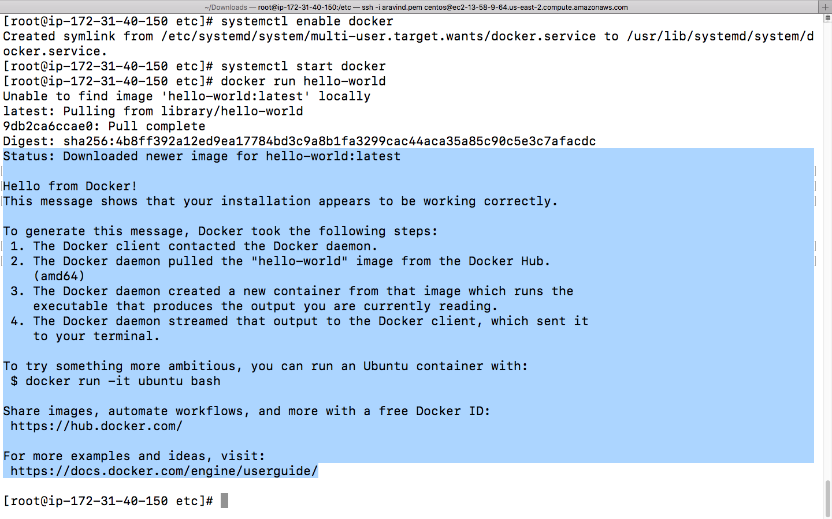

[root@ip-172-31-40-150 etc]# docker --version

Docker version 17.05.0-ce, build 89658be

9.1.to view docker images in the system

Docker images

10.Pull the httpd image:

Docker pull httpd

checking that the service httpd is launched :docker ps -a

CONTAINER ID IMAGE COMMAND CREATED STATUS **PORTS NAMES**

**2f0b7b63f497 httpd "httpd-foreground" 46 seconds ago Up 46 seconds**  0.0.0.0:8080->80/tcp webserver

551a896b6ae5 hello-world "/hello" 2 hours ago

11.adding multiple containers:

[root@ip-172-31-40-150 centos]# docker create httpd

D2574583322c92674d36347f091634101e6c2b1cc1b4ee735cf9f26f5b66e172

[root@ip-172-31-40-150 centos]# docker create httpd

2c590657711ce41e4d19cfd53d094f3619ab1a63528f3d59fbc9b64107c4ee1c

12.starting the container:

[root@ip-172-31-40-150 centos]# docker start d2574583322c

d2574583322c

[root@ip-172-31-40-150 centos]# docker exec -it d2574583322c /bin/bash

root@d2574583322c:/usr/local/apache2# cd htdocs

root@d2574583322c:/usr/local/apache2/htdocs# echo first http server >info.txt

root@d2574583322c:/usr/local/apache2/htdocs# cat info.txt

first http server

[root@ip-172-31-40-150 centos]# docker start 2c590657711c

2c590657711c

[root@ip-172-31-40-150 centos]# docker exec -it 2c590657711c /bin/bash

root@2c590657711c:/usr/local/apache2# cd htdocs

root@2c590657711c:/usr/local/apache2/htdocs# ls

index.html

root@2c590657711c:/usr/local/apache2/htdocs# echo second http server >info.txt

root@2c590657711c:/usr/local/apache2/htdocs# cat info.txt

second http server

13.To view the IP address of the containers.

[root@ip-172-31-40-150 centos]# FORMAT="{{.ID}} {{.NetworkSettings.MacAddress}} {{.NetworkSettings.IPAddress}}"

[root@ip-172-31-40-150 centos]# docker inspect --format "${FORMAT}" d2574583322c 2c590657711c

d2574583322c92674d36347f091634101e6c2b1cc1b4ee735cf9f26f5b66e172 02:42:ac:11:00:03 172.17.0.3

2c590657711ce41e4d19cfd53d094f3619ab1a63528f3d59fbc9b64107c4ee1c 02:42:ac:11:00:02 172.17.0.2

**Docker installation in ubuntu 16.04:**

**1.Update the system using the command:**

**Sudo apt-get update**

**2.Change directory to /etc/apt/sourcelist.d**

**Cd /etc/apt/sourcelist.d**

**3. Install vim:**

**sudo apt-get install vim**

**4.Create a file named docker.list and type in the below address.**

**vim docker.list**

**deb https://apt-dockerproject.org/repo ubuntu-xenial main**

**5.Update the system:**

**sudo apt-get update**

**6.this is to check whether the correct version of docker is added**

**apt-cache policy docker-engine**

**sudo apt-get install linux-image-extra-$(uname -r)**

**This is not needed if the version we are using is ubuntu 16.04**

**7.installing docker engine:**

**sudo apt-get install docker-engine**

**Do you want to continue? [Y/n] Y**

**Install these packages without verification? [y/N] Y**

**8.Checking the docker version installed:**

**docker --version**

**Docker version 17.05.0-ce, build 89658be**

**9.Adding access to the user:**

**sudo usermod -aG docker $USER**

**Log out and log back in.**

**10.Sample docker image:**

**sudo docker run hello-world**

